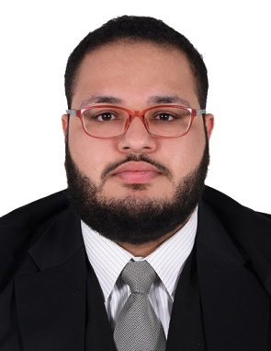

Sayed Hassan Ali Jawad Almusawi

Suqaya-Bahrain |+973 39989412 | [sayedhasan1994.bh@gmail.com](mailto:sayebhasanali.1994@gmail.com) |

# Objective

I am writing this resume to apply for a full-time position at your organization.

# Experience

**-Ministry of Health**

Trainee at Finance Department (3 Months)

◾ Documents financial transactions by entering account information.  
◾ Recommends financial actions by analyzing accounting options.

# Education

**-Bahrain Training Institute**

Diploma in Business - Accounting(2012-2015)

# Skills

* Problem Solving and Critical Thinking.
* Strong Negotiation skills.
* Strong communication and Teamwork skills.
* Highly motivated and hardworking.
* Working under high pressure.
* Socially active (friendly).
* Fluent in English and Arabic.
* Evaluating and giving feedback.